**Abstract**

Existing theories describing faceted growth and ablation of ice crystals have significant limitations in terms of the connection to the underlying physical processes. In filling that knowledge gap, the present model provides insights and predictive power about faceted growth and ablation that have not been possible previously. For example, the model predicts that growing facets will be slightly concave, and that the slope of that concavity will increase in proportion to the square root of the surface diffusivity.

1. **Prior theories of faceted ice crystal growth and ablation**

The BCF picture is clearly wrong between 240 K and melting, in that the surface of real ice is covered by a quasi-liquid layer (QLL) whose efficiency at capturing incoming water vapor molecules is close to 100%.

The quasi-liquid continuum model introduced by some of the authors in 2016 (N2016) therefore recast the surface as two spatial variables that interact with one another over time. In that formalism, one variable, $N_{tot}$, represents the total thickness of the ice surface (black curve in Fig. 1). A second variable, $N_{QLL}$, represents the thickness of just the quasi-liquid part of $N_{tot}$ (vertical distance between curves in Fig. 1).

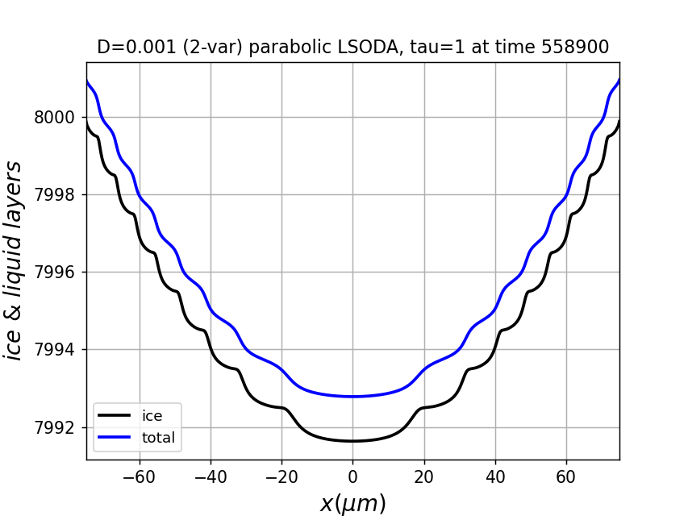

**Fig. 1**. Visual representation of $N_{tot}$ and $N_{QLL}$ in the N2016 (and present) model.

Key atomistic processes introduced in N2016 were: (i) surface diffusion of the quasi-liquid across the facet, and (ii) partial freezing and melting of the quasi-liquid in response to the addition of water from the vapor phase.

The N2016 model suffered from several limitations, however, of which the most important for our present purpose is that the time scale of process (ii) was implicitly fixed, whereas in actuality that time scale can be expected to vary with temperature and with the nature of the underlying facet.

1. **A revised quasi-liquid continuum model**

The model introduced here is defined by

$\frac{{dN}_{tot}}{dt}=D∇^{2}N_{QLL}+ν_{kin}σ_{m}$ (1a)

$\frac{{dN}_{QLL}}{dt}=\frac{{dN}_{tot}}{dt}+\left(N_{QLL}-N_{QLL}^{eq}(N_{tot})\right)/τ_{eq}$ (1b)

Some notes about this model are as follows:

* 1. represents the idea that surface diffusion depends on the thickness of the quasi-liquid only; the underlying ice is considered immobile on time scales considered here.
  2. $ν_{kin}$ is the rate of exchange of water between the facet and the vapor phase
  3. $σ_{m}$ is the fractional difference between these values (i.e., the surface supersaturation), given by …
  4. $N_{QLL}^{eq}(N_{tot})$ defines the thickness of quasi-liquid when it is in equilibrium with the underlying ice. Here (as in N2016) we use the sinusoidal form

(2)

* 1. is a first-order relaxation constant describing the time scale at which quasi-liquid/ice equilibrium is achieved. That is, if we imagine an initial situation having an amount of quasi-liquid given by $N_{QLL}^{o}$, then (in the absence of diffusion) it is assumed that equilibration after a time $Δt$ occurs according to

$N_{QLL}\left(t\right)=N_{QLL}^{eq}\left(N_{tot}\right)+\left(N_{QLL}^{o}-N_{QLL}^{eq}\left(N_{tot}\right)\right)e^{-\frac{Δt}{τ_{eq}}}$ (3)

If one takes the time derivative of Eq. (3), and assumes that $Δt$ is small, the second term on the right-hand side of Eq. (1b) results.

The difference between the present model and N2016 lies in the treatment of the quasi-liquid equilibration just described. In practice, this means that the expression for $\frac{{dN}_{QLL}}{dt}$ given in Eq. (1b) here is different from the corresponding expression in N2016 (Eq. (5b)). The strength of the present formulation is that we are able to parameterize the relative rates of diffusion and quasi-liquid/ice equilibration; it also means that we have an additional parameter, $τ_{eq}$, that we must determine. Although we do not have reliable independent guides for determining a physically realistic range of value for $τ_{eq}$, we do have a guidepost: because the “diffusive slowdown” mechanism for stabilization of faceted ice growth described in N2016 required that quasi-liquid/ice equilibration be slow compared to surface diffusion, we should not be surprised if large $τ_{eq}$ leads to stable growth scenarios. We return to this topic presently.

1. **Implementation details**

Python, accelerated with Numby.

1. **Results**

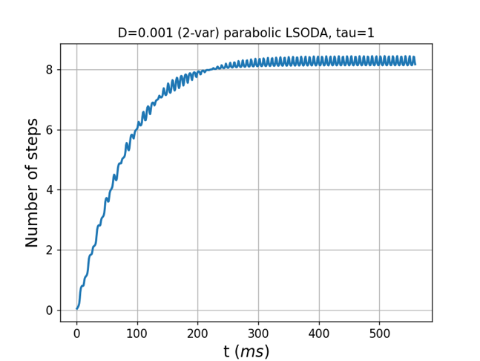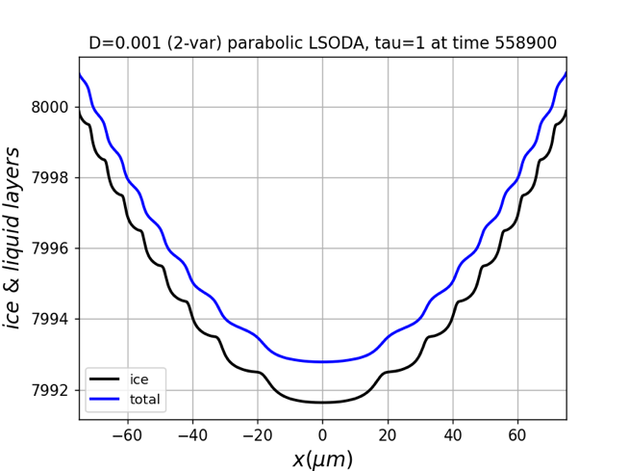

**Fig. 2**. …

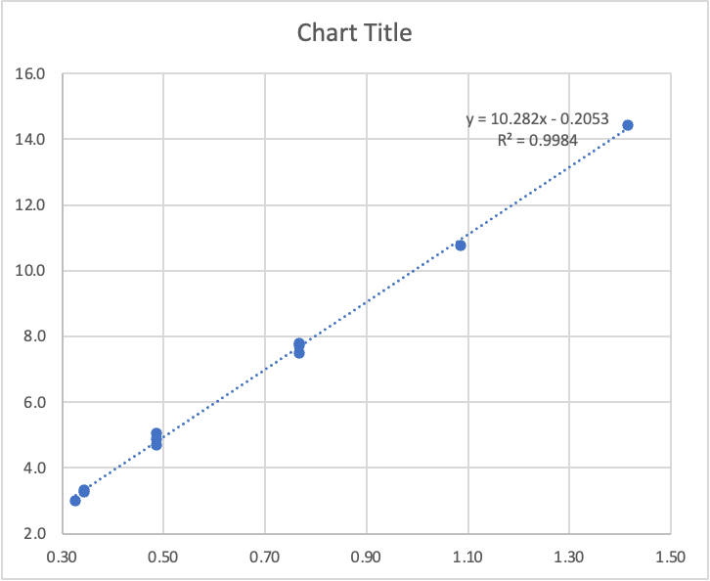 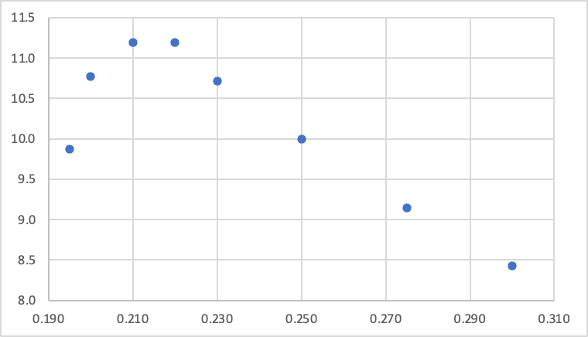

**Fig. 3**. Left: Surface layer wavelength ($λ$) as a function of the dimensionless parameter ${z≡\left(\frac{D}{c_{r}ν_{kin}}\right)}^{\frac{1}{2}}×10$. Right: $λ$ as a function of the corner supersaturation $σ_{corner}$.